CN ASSIGNMENT 4
Q.1 Create a pool on the DHCP Server router, named “xyz” and follow all the requirements.
1. Client should use the DNS server with the IP address: 1.2.3.4 2. Client should use the network 192.168.10.0/24
3. Client should renew their IP address after every 3 hours
4. Make sure, Router does not respond to any BOOTP
5. Configure the Client so that it will obtain IP from DHCP server.

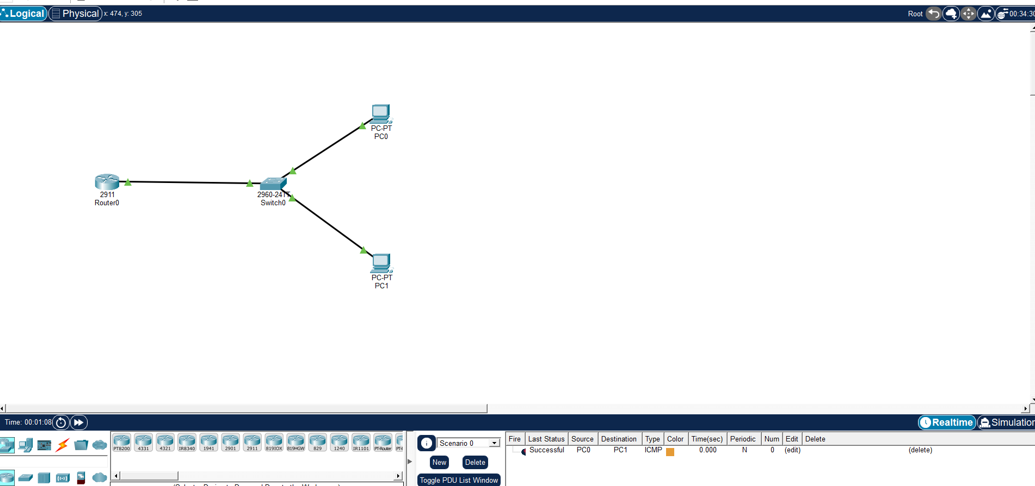
Commands for router:
enable
configure terminal
interface gig 0/0/0
ip address 192.168.10.1 255.255.255.0
no shut
exit
Exclude IP for router itself
ip dhcp excluded-address 192.168.10.1
Create DHCP Pool XYZ
ip dhcp pool xyz
network 192.168.10.0 255.255.255.0
default-router 192.168.10.1
dns-server 1.2.3.4
lease 0 3 ! (0 days, 3 hours)
exit
Disable BOOTP Services
no ip bootp server
Save Configuration
end
write memory

